**Supplemental Software Guide**

*ImageJ Macro*

The ‘NanoSPD_Batch_Trace’ macro is provided as Supplemental Materials and can be installed in ImageJ using the command (Plugins:Macro:Install).

*MATLAB*

Fully commented MATLAB source code is provided as Supplemental Materials, including precompiled executables for use with MacOS and Windows that can be run without a MATLAB license. These executables require the MATLAB Compiler Runtime libraries be installed as a prerequisite (R2013a, v8.1). Installers are freely available for download at [http://www.mathworks.com/products/compiler/mcr/.](http://www.mathworks.com/products/compiler/mcr/)

**Line Tracing**

*Imaging recommendations*

To extract the maximum information from filopodia line scans, microscope images should have a 12 or 16 bit depth and exceed the Nyquist sampling criterion wherever possible (i.e. the pixel size should be less than half the Abbe resolution limit). For microscopes with a high N.A. objective ( > 1.4), this requires an effective pixel size of ~100 nm. The output image format (LSM, etc.) must be correctly calibrated in microns. If the calibration is not correctly imported to ImageJ, this can be set prior to measuring line scans (Image:Properties). Investigators should be blinded at all stages of imaging and subsequent line tracing with respect to the bait and prey combinations being tested. Cells should be sufficiently spaced. If cells are seeded too close to one another, filopodia may extend underneath neighboring cells and line scans may not represent a true measure of bait-prey trafficking.

*ImageJ Workflow*

1. Open a multi-channel image file in ImageJ (e.g. LSM, if using Zeiss microscopes and software).
2. Adjust contrast (Image:Adjust:Brightness + Contrast) of the BAIT and PHALLOIDIN channels, so that filopodia shafts are clearly visible. This operation does not affect the raw data values, only how they are being mapped to the display.
3. Briefly reveal the PREY channel to confirm expression. The PREY remains hidden during the remainder of the line tracing process to avoid selection bias.
4. Open the region of interest (ROI) manager (Analyze:Tools:ROI Manager).
5. Set line width to 2-4 pixels (Edit:Options:Line Width), so that the full width of the filopodia shaft is covered. Trace a single filopodium with the segmented line tool, using either the PHALLOIDIN or BAIT channels as a template.

**Critical:** Start tracing from the base of the filopodium and continue for several microns past the tip.

**Critical:** Avoid very short filopodia (< 2 microns).

**Critical:** Trace filopodia that have a visible accumulation of BAIT at their tips.

1. Add line trace to ROI Manager (shortcut: press ‘t’).
2. Repeat tracing filopodia and adding to ROI Manager until up to 10 filopodia are stored.
3. Select ROIs and save to file (optional) in ROI Manager.
4. Delete PHALLOIDIN channel (Image:Stacks:Delete Slice).

**Critical:** Only BAIT and PREY (i.e. 2 channels) can be present when running the macro.

1. Run “NanoSPD_Batch_Trace” macro (Plugins:Macro:Run) to export all the line traces from the image into a tab-delimited text file. When prompted, enter the filename to export to.

**Critical:** Save the filename with a .TXT extension, not the ImageJ default .XLS. We recommend matching this file name to its corresponding image name.

1. Delete ROIs in ROI Manager.
2. Close image file **without** saving changes.
3. Repeat steps 1 to 12 for each cell. Using this workflow, 10 filopodia from one cell can be traced in < 5 minutes.

**Analysis in MATLAB**

Line tracing is used to sample bait and prey fluorescence along individual filopodia so that comparisons can be made between the tip (where bait and prey complexes accumulate) and the filopodia shaft to take an estimate of background signal intensity.

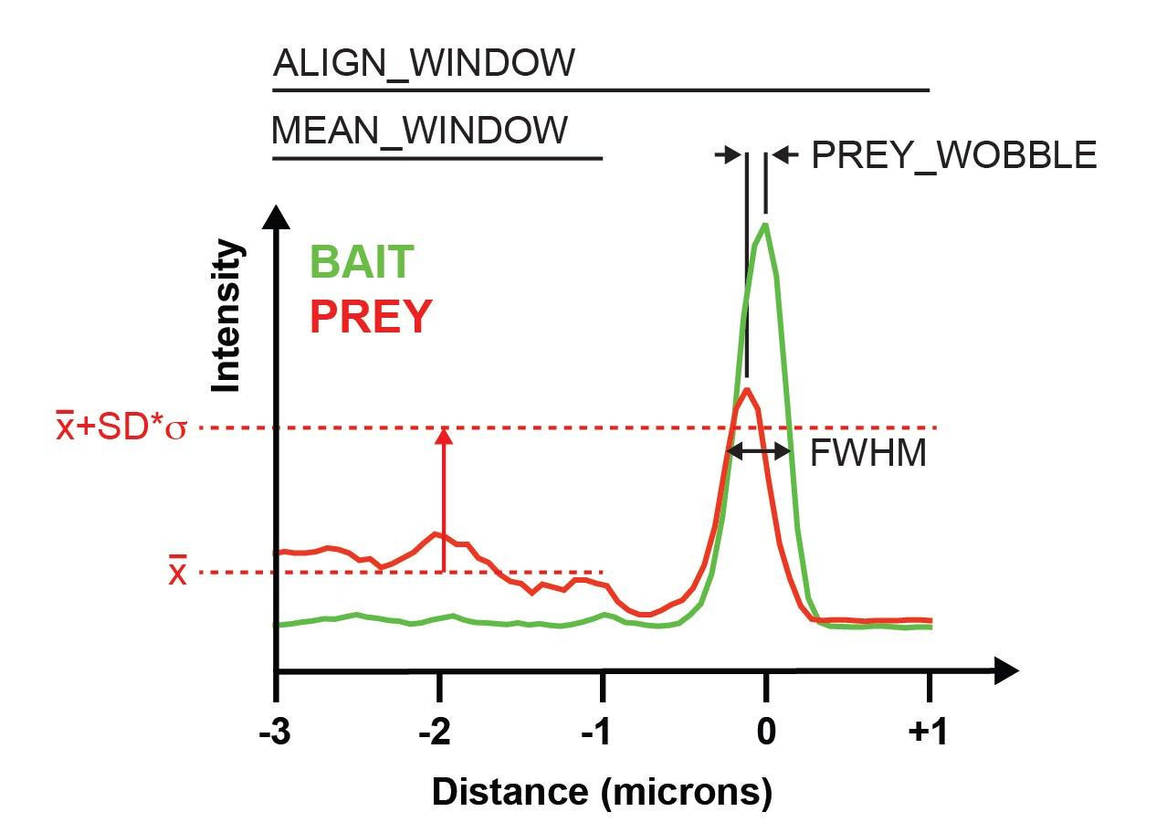

*Figure Legend: An example line scan showing analysis parameters defined within the NanoSPD MATLAB tool (see below for description). Distances are relative to the filopodium tip (z = 0), with negative values moving towards the filopodium base . Bait and prey fluorescence are separately compared against their respective means ($\underline{x}$) within the interval, MEAN_WINDOW. A threshold is set by a multiple (SD) of standard deviations (σ) above this mean. Supra-threshold fluorescence at the filopodia tips is combined with permutation analysis to assess the statistical significance of the calculated correlation (Pearson’s r) between bait and prey.*

*Analysis parameters*

ALIGN_WINDOW[lower bound..upper bound]

Sets the range (in µm) of a line scan that are displayed by the program. The filopodium tip is defined as 0 µm (+ve distances are away from the cell body, -ve is towards). The interval between lower and upper must include 0 (the filopodium tip). During initial quality filtering, filopodia that do not not extend to cover this range are excluded.

MEAN_WINDOW[lower bound..upper bound]

Sets the range (in µm) over which to measure mean and standard deviation of bait and prey fluorescence along the shaft of the filopodium. This is used in combination with the parameter SD to generate a threshold to detect fluorescence increases significantly above background.

SD

Sets the multiple of standard deviations used to set the threshold for detecting significant deviations from background along the shaft of the filopodium.

FWHM

Defines the maximum full-width at half maximum (µm) of the bait signal at the filopodia tips. Line scans exceeding this are excluded from further analysis.

PREY_WOBBLE

Defines the distance (in µm) from the filopodium tip (i.e. the maximum bait signal, z = 0), that can be searched to find the maximum prey signal. Accounts for aberrations in the optical path that can cause different wavelength signals to be shifted laterally.

BLOCK_SIZE

Set the block size (in µm) used to resample and randomize the prey line scan during permutation testing. Specific to spatial correlation analysis.

BLOCK_TRIALS

Sets how many cycles of permutation testing. Specific to spatial correlation analysis.

PERCENTILE

Defines the percentile (0 - 100%) of the exact distribution of Pearson’s *r*-values to assign significance. For example, the 99th percentile is equivalent to a one-tailed P-value of 0.01 (1 - 0.99). Specific to spatial correlation analysis.

Correlation Mode

Select ‘Pearson’ (default) or non-parametric ‘Spearman’ for calculating correlation. Specific to spatial correlation analysis.

Interaction Mode

Select ‘Threshold + Correlation’ (default), ‘Threshold only’ or ‘Correlation only’ to set how a positive interaction is scored. Specific to spatial correlation analysis.

Data Input Format

Sets the data order expected in input TXT batch line scan files. Select between ‘Distance:Prey:Bait’ and ‘Distance:Bait:Prey’. ImageJ exports line scan data matching the channel order in the source image file i.e. if the image file has Channel 1 as PREY and Channel 2 as BAIT, the data order input should be set to ‘Distance:Prey:Bait’.

**CRITICAL:** All TXT files in the input directory MUST have the same data order.

*MATLAB Workflow*

1. Organize data so that all .TXT data files for each condition are grouped together into a single directory. MATLAB will import all .TXT files in this directory for analysis.
2. Start the program from the command line (type ‘NanoSPD’ into the MATLAB console) , or by clicking on the compiled executable.

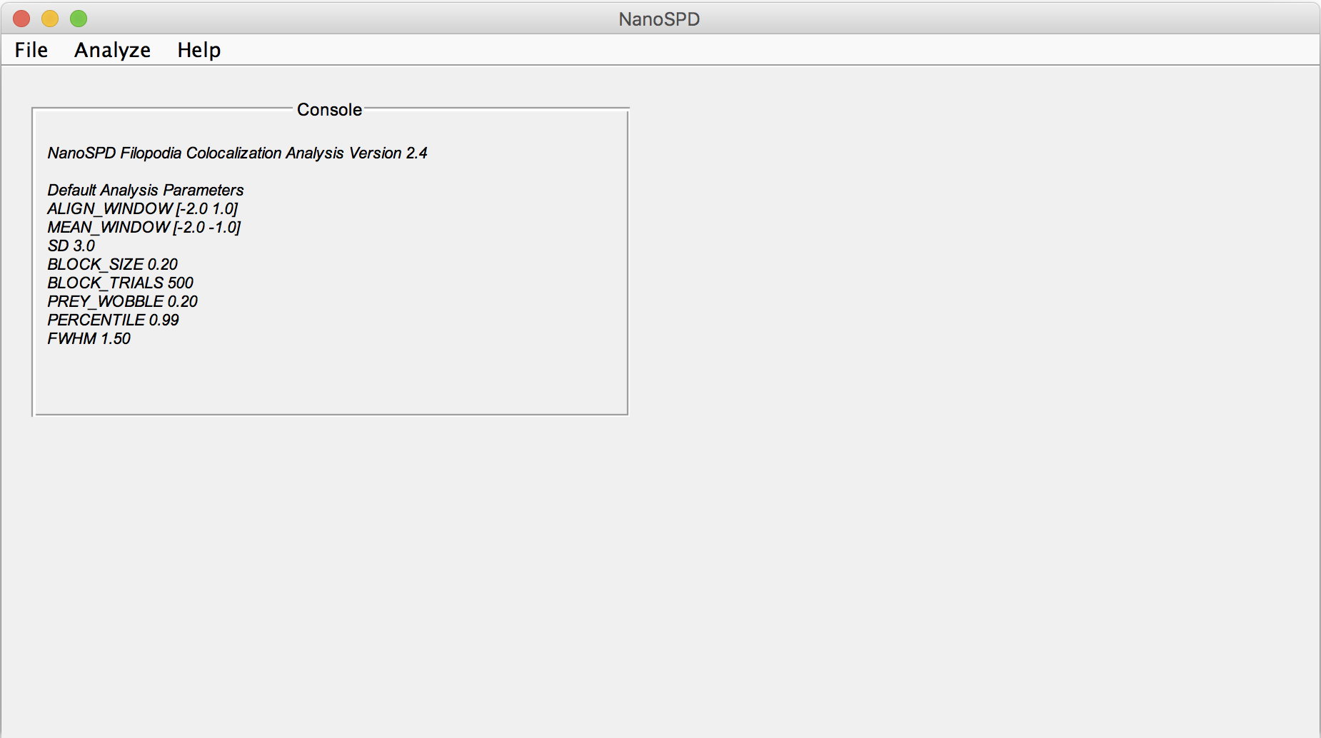

*Figure Legend: Main program window and console showing default analysis parameters.*

1. Set analysis options (Analyze:Options). See above for a definition of these parameters. **CRITICAL:** Data input format must be set before importing.

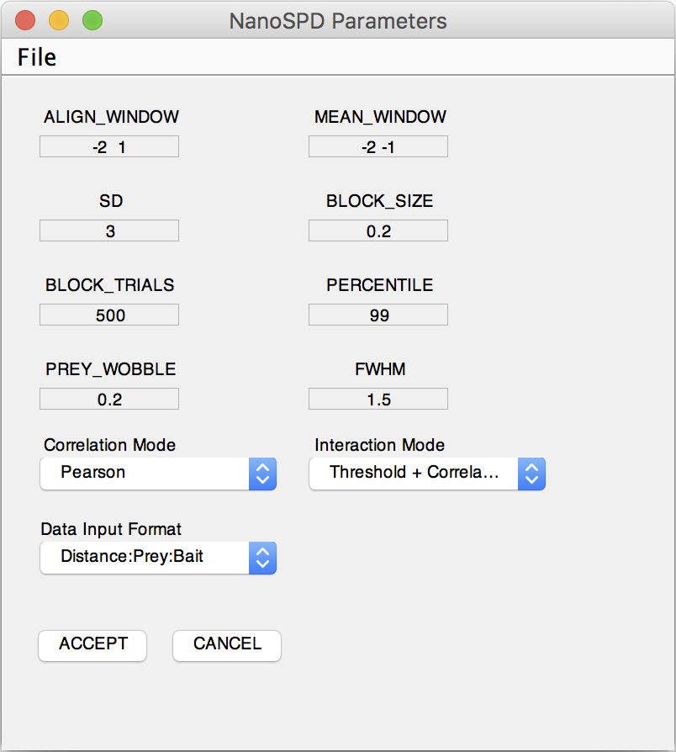

*Figure Legend: Analysis options. See definitions above.*

1. Load data (File:Open Batch Filopodia). Select a directory containing filopodia traces.
2. Run analysis (Analyze:Run Analysis).
3. Review individual filopodia traces (using the scroll bar). There are four main panels.
   1. Top left: Console. Displays the file path and ID # for the current filopodium. Also displays the numerical bait and prey thresholds that must be exceeded to indicate a significant increase over background, and whether these were exceeded. Console turns blue in the presence of an interaction detected by spatial correlation analysis. Individual traces can be excluded or included from the exported data set by clicking the check box.
   2. Top right: Line scan data. Bait fluorescence line scans (green), and prey (red), are colored irrespective of fluorophores used. Data are aligned at the filopodium tip (z = 0 µm). Fluorescence is normalized to the maximum value within the window. Horizontal dotted lines indicate the bait and prey thresholds displayed in the console.
   3. Lower left: Cross-correlation between bait and prey line scans.
   4. Lower right: Exact distribution of Pearson’s *r* values by permutation testing. Vertical lines equal actual calculated *r*-value (solid line), and the 99th percentile (i.e. P = 0.01) of the distribution (dotted line) .

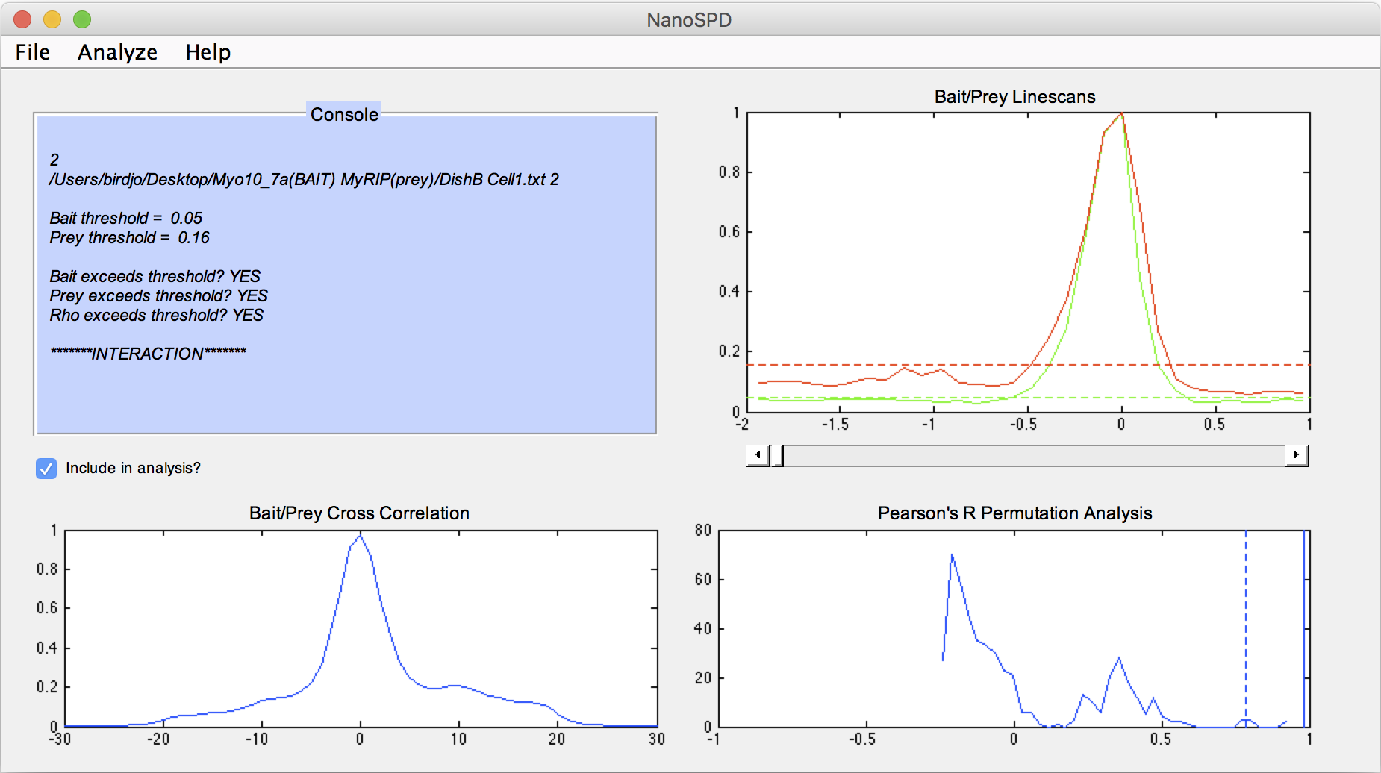

*Figure Legend: Results window showing line scans and summary information for each filopodium. Each filopodium can be reviewed by using the scroll bar below the Bait/Prey line scans.*

1. Save filopodia database as a .MAT file (File:Save Analysis to File). This saves the state of the entire program, including the current filopodia database, and results of permutation analyses, so that it can be opened again in the future.
2. Export a summary image (Analyze:View Summary Traces). MATLAB will prompt for a filename to save as (and file format). This image visually summarizes all of the line scan data in the database, with bait (green) and prey (prey) line scans paired together. Filopodia determined as interaction are in the left column, and non-interacting in the right column. Filopodia omitted from analysis (due to quality filtering, or manual removal) are represented by a blank space.

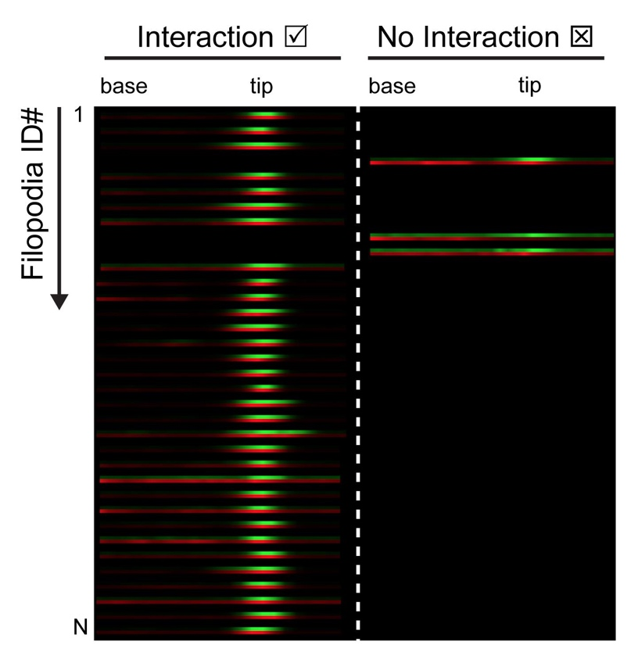*Figure Legend: Summary image format sorts filopodia line scans into ‘Interaction’ (left column) and ‘No Interaction’ (right column) based upon the Interaction Mode (i.e. Threshold, Correlation or Threshold + Correlation). Bait (green) and prey (red) horizontal line scans are represented as pairs stacked vertically. Filopodia excluded from analysis are omitted.*

1. Export a summary .CSV file of analysis results. This can be open viewed in Excel.
2. Close database (File:Close).

**Preparing Results for Intensity and Spatial Correlation Analysis**

Summary results for both intensity and spatial correlation are assembled from the .CSV output file. The output file header contains a summary of the analysis parameters, and results listed one filopodium per row. “Bait Significant?”, “Prey Significant?”, “R Significant?” and “Overall Interaction?” are Boolean values, with 1 = YES, and 0 = NO.

*Spatial Correlation Analysis*

The interaction index *I = A / B,* where *A* is number of filopodia flagged with “Overall Interaction” = 1, and B is the total number of filopodia. This calculation is automatically appended to the end the CSV output file.

*Intensity Correlation Analysis*

To create scatter plots of bait and prey intensity (see Figure 3E), for each filopodium plot the corresponding RAW_BAIT_MAX (X) vs RAW_PREY_MAX (Y) from the CSV file. These values are the raw fluorescence intensities detected at the filopodia tips. For plotting the raw amplitudes of the prey fluorescence alone (see Figure 3F), plot all RAW_PREY_MAX values as as a bar graph.

**Trouble Shooting**

*Line scan files are not opened by MATLAB*

Input line scan files are skipped if not correctly formatted. It is critical to use the NanoSPD_Batch_Trace macro to export line scans from the ImageJ ROI manager. Files must be named with a ‘.TXT’ extension to be correctly opened.

*Majority of line scans are excluded by MATLAB*

The ‘Data Input Format’ set in Analysis Settings may not match the actual order in the input .TXT files, leading MATLAB to incorrectly search for the filopodium tip using the PREY signal. Ensure that this setting matches the data order in .TXT line scan files.

*What if my line scans files have a mixture of data order?*

Organize line scan files into directories with matching data order and analyze them separately. Once exported to the .CSV format, summary data can be easily recombined in Excel.